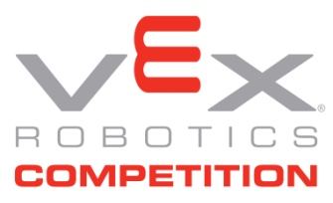
VEX VRC Results 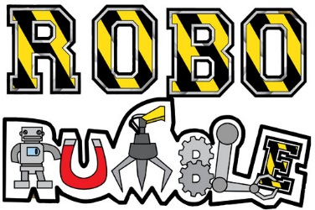
Contact:
NAME: Pamela Howell
PHONE: 485-3646
E-MAIL: pamela.howell@jefferson.kyschools.us

TWO JEFFERSONTOWN HIGH SCHOOL TEAMS TAKE THE TITLE OF TOURNAMENT CHAMPIONS AT THE Regional ROBORUMBLE VEX VRC ROBOTICS COMPETITION
Three JCPS high school teams move on to the VEX High School State competition on Sat. March 5, 2016. JCPS also had one middle school team that will move on to VEX Middle School State competition on Sat. Feb. 27, 2016. Both tournaments will be in Elizabethtown, Kentucky.
Here are the results from Saturday, Feb. 20, 2016 RoboRumble Regional Tournament:
Tournament Champions: Excellence Award:
School: Jeffersontown High School School: Meyzeek Middle School
Team #: 9600B Team #: 99226
Team Name: Jtown B Team Name: Meyzeek Bear Bots-EDR

Tournament Champions: Design Award:
School: Jeffersontown High School School: Central High School
Team #: 9600C Team #: 99451
Team Name: Jtown C Team Name: Louisville Centrons

Other Award Winners:
Judges Award Sportsmanship Award:
School: Olmsted Academy North Middle School School: Academy @ Shawnee High School
Team #: 98605 Team #: 99099A
Team Name: Colts Engineering EDR Team Name: Eagles Gold

